ASSIGNMENT 1

- Describe architecture of RDBMS. Also how RDBMS supports integrity and atomicity.

ANS 1:
The design of a DBMS depends on its architecture. It can be centralized
or decentralized or hierarchical. The architecture of a DBMS can be seen as either single tier or multi-tier. An n-tier architecture divides the whole system into related but independent n modules, which can be independently modified, altered, changed, or replaced.

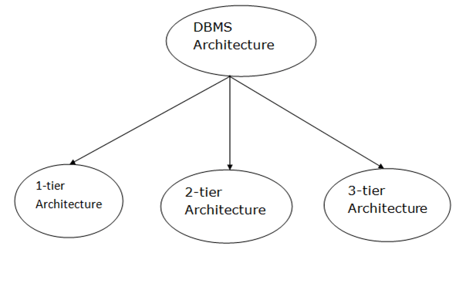
The design of a DBMS depends on its architecture. It can be centralized or decentralized or hierarchical. The architecture of a DBMS can be seen as either single tier or multi-tier. The tiers are classified as follows :
- 1-tier architecture
- 2-tier architecture
- 3-tier architecture
- n-tier architecture

- Tier Architecture.

o In this architecture, the database is directly available to the user. It
means the user can directly sit on the DBMS and uses it.

o Any changes done here will directly be done on the database itself. It
doesn't provide a handy tool for end users.

o The 1-Tier architecture is used for development of the local
application, where programmers can directly communicate with the
database for the quick response.

FIG. OF 1 TIER ARCHITECTURE.

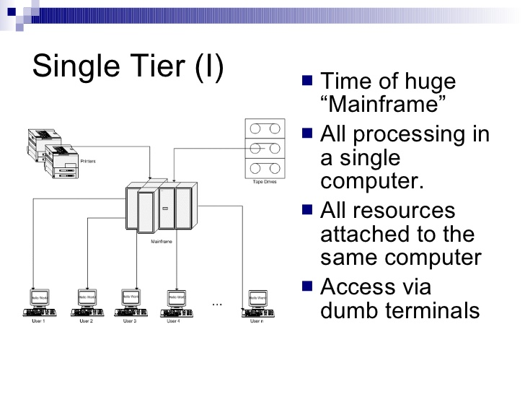
- Tier Architecture.
o The 2-Tier architecture is same as basic client-server. In the two-tier
architecture, applications on the client end can directly communicate
with the database at the server side. For this interaction, API's
like: ODBC, JDBC are used.

o The user interfaces and application programs are run on the
client-side.
o The server side is responsible to provide the functionalities like: query
processing and transaction management.

o To communicate with the DBMS, client-side application establishes a
connection with the server side.

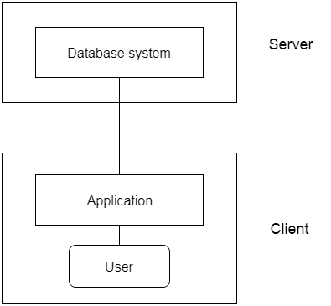

FIG. OF 2 TIER ARCHITECTURE.

3-Tier Architecture.
o The 3-Tier architecture contains another layer between the client and
server. In this architecture, client can't directly communicate with the
server.

o The application on the client-end interacts with an application server
which further communicates with the database system.

o End user has no idea about the existence of the database beyond the
application server. The database also has no idea about any other
user beyond the application.

o The 3-Tier architecture is used in case of large web application.

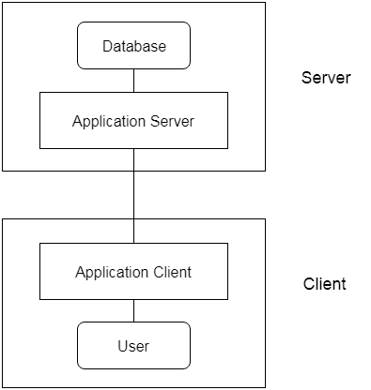

FIG. OF 3 TIER ARCHITECTURE.

● Atomicity −

This property states that a transaction must
be treated as an atomic unit, that is, either all of its operations
are executed or none. There must be no state in a database
where a transaction is left partially completed. States should be
defined either before the execution of the transaction or after
the execution/abortion/failure of the transaction.

Consistency −

The database must remain in a consistent
state after any transaction. No transaction should have any
adverse effect on the data residing in the database. If the
database was in a consistent state before the execution of a
transaction, it must remain consistent after the execution of the
transaction as well.

● Durability −

The database should be durable enough to
hold all its latest updates even if the system fails or restarts. If a
transaction updates a chunk of data in a database and commits,
then the database will hold the modified data. If a transaction
commits but the system fails before the data could be written on
to the disk, then that data will be updated once the system
springs back into action.
Isolation −

In a database system where more than one
transaction are being executed simultaneously and in parallel,
the property of isolation states that all the transactions will be
carried out and executed as if it is the only transaction in the
system. No transaction will affect the existence of any other
transaction.

- What are the different types of languages that are available in the DBMS?

ANS 2:

Types of Database Language.

● DDL stands for Data Definition Language.
● DML stands for Data Manipulation Language.
● DCL stands for Data Control Language.
● TCL stands for Transaction Control Language.

DATA DESCRIPTION LANGUAGE.
A data definition or data description language (DDL) is a syntax similar to a computer programming language for defining data structures, especially database schemas. DDL statements create and modify database objects such as tables, indexes, and users. Common DDL statements are CREATE, ALTER, and DROP.

DATA MANIPULATION LANGUAGE.

A data manipulation language (DML) is a computer programming language used for adding (inserting), deleting, and modifying (updating) data in a database. A DML is often a sublanguage of a broader database language such as SQL, with the DML comprising some of the operators in the language

Data Control Language.

A data control language (DCL) is a syntax similar to a computer programming language used to control access to data stored in a database (Authorization). In particular, it is a component of Structured Query Language (SQL).
Examples of DCL commands include:
GRANT to allow specified users to perform specified tasks.
REVOKE it is remove the user accessibility to database object.

Transaction Control Language.

Transaction Control Language commands are used to manage transactions in the database. These are used to manage the changes made by DML-statements. It also allows statements to be grouped together into logical transactions.

- What do you mean by data model? Explain various types of data model.

ANS 3:

Data models define how the logical structure of a database is modeled. Data Models are fundamental entities to introduce abstraction in a DBMS. Data models define how data is connected to each other and how they are processed and stored inside the system.
The very first data model could be flat data-models, where all the data used are to be kept in the same plane. Earlier data models were not so scientific, hence they were prone to introduce lots of duplication and update anomalies.
Relational Model.
The relational model represents the database as a collection of relations. A relation is nothing but a table of values. Every row in the table represents a collection of related data values. These rows in the table denote a real-world entity or relationship.

Entity-Relationship Data Model.
An ER diagram shows the relationship among entity sets. An entity set is a group of similar entities and these entities can have attributes. In terms of DBMS, an entity is a table or attribute of a table in database, so by showing relationship among tables and their attributes, ER diagram shows the complete logical structure of a database. Lets have a look at a simple ER diagram to understand this concept.

- Object-based Data Model.

An extension of the model with notions of functions, encapsulation, and obidentity, as well. This model supports a rich type systethat includes structured and collection types. Thus, in 1various database systems following the object-oriented approach were developed. Here, the objects are nothing the data carrying its properties.

- Semistructured Data Model.

This type of data mis different from the other three data models (explaineabove). The semistructured data model allows the datspecifications at places where the individual data items the same type may have different attributes sets. The Extensible Markup Language, also known as XML, is wused for representing the semistructured data. AlthougXML was initially designed for including the markup information to the text document, it gains importance because of its application in the exchange of data.

- Explain the concept of partial and complete participation in ER diagram?

ANS 4:

Total Participation :-

Total Participation is when each entity in the entity set occurs in atleast one relationship in that relationship set. Entity fully participate in the relationship indicate by double lines drawn from entity to relationship. Cannot have a null value for attribute in total participation side.

Partial Participation :-

Partial Participation is all entities do not involve in the relationship
Entity partially participate in the relationship indicate by single
lines drawn from entity to relationship.

- Write SQL and relational algebra queries for schema emp(emp_id,name,address,age) Job (job_id, emp_id,job_type) a. List all employees with id 123 and 234. b. List name of employees having age less than 40 and belongs to “ Dehradun”. c. Calculate average and maximum age from emp.(give sql query only) d. Display job_id and emp_name for employees working in “medical” department.

ANS 5:

